**15.ticketraisingapp**

**Step-1:Created a react app with name ticketraisingapp**

**>npx create-react-app ticketraisingapp**

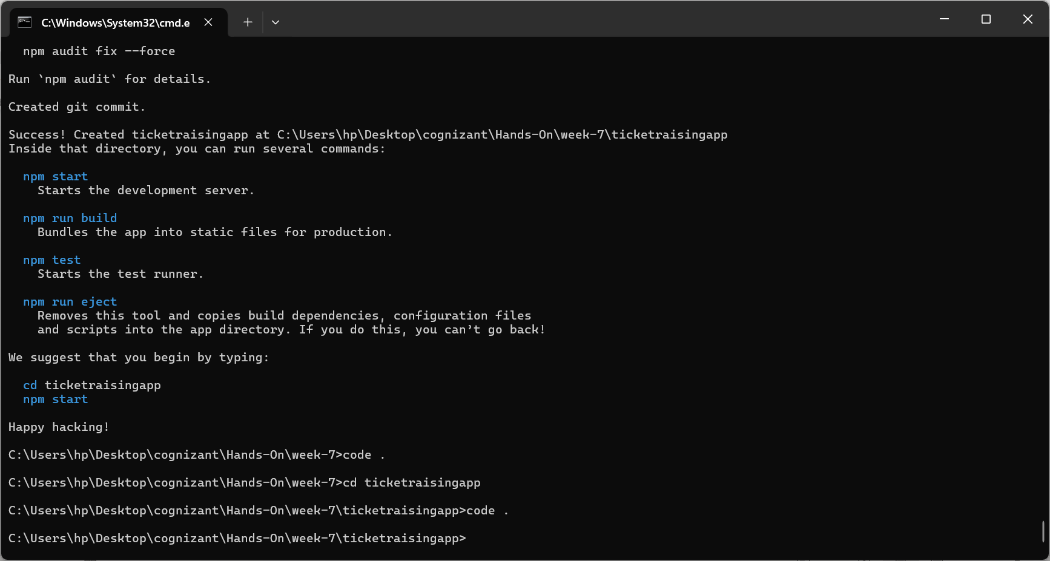

**Step-2:**

**Created a class component complaintregister.js which uses eventhandlers like HanldChange(), HandleSubmit()**

**ComplaintRegister.js**

import React, { Component } from 'react';

export class ComplaintRegister extends Component {

  constructor() {

    super();

    this.state = {

      ename: '',

      comp: '',

      NumberHolder: Math.floor(Math.random() * 10000)

    };

    // Binding event handlers  - new concept

    //This tells JavaScript:“No matter how or where handleChange is called, always use the this from this class instance.”

    this.handleChange = this.handleChange.bind(this);

    this.handleSubmit = this.handleSubmit.bind(this);

  }

  handleChange(event) {

    this.setState({ [event.target.name]: event.target.value });

  }

  handleSubmit(event) {

    var msg = 'Thanks ' + this.state.ename +

              '\nYour Complaint was Submitted' +

              '\nID is: ' + this.state.NumberHolder;

    alert(msg);

    event.preventDefault();

  }

  render() {

    return (

      <div value="form">

        <label>name:</label>

        <input  name="ename" value={this.state.ename} onChange={this.handleChange}/>

        <br/>

        <label>Complaint:</label>

        <textarea name="comp" value={this.state.comp} onChange={this.handleChange}/>

        <br/>

        <button onClick={this.handleSubmit}>submit</button>

      </div>

    );

  }

}

**App.js**

import { ComplaintRegister } from "./ComplaintRegister";

function App() {

  return (

    <div className="App">

      <h1 style={{color: "red"}}>Register your Complaints!!!</h1>

      <ComplaintRegister />

    </div>

  );

}

export default App;

**Step-3:**

**Output:**

